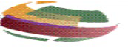
DARK BOX – 200 mm systems and below
DATA SHEET
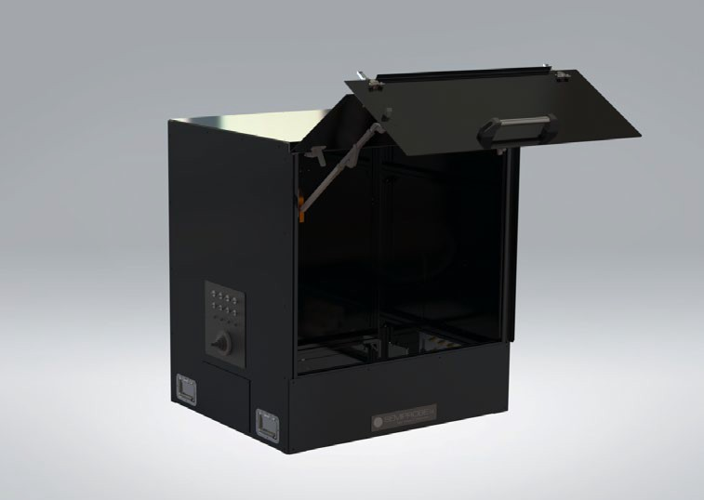
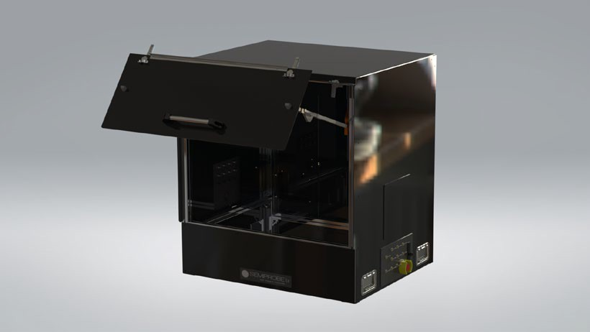
The SemiProbe Dark Box provides the user a clear visual path to instrumentation and controls located outside and adjacent to the system. The unique design of the dark box ensures easy access to the probe system and test instrumentation controls while minimizing its operational footprint and conserving expensive lab space. Further, unlike other designs, during setup, the user has full access to the prober and test equipment controls. The dark box is provided with interconnect panels on both sides. One interconnect panel is usually supplied with application specific feed through connectors (coaxial, triaxial, high voltage, high current, high frequency and more). The interconnect panel also has a rubberized boot that allows direct pass through of cables (high frequency, fibers and more). The other interconnect panel is blank to allow for customization by the customer. The rear of the box has a light trap feedthrough that allows easy insertion of prober control cables, illuminator light source, thermal chuck cable/cooling lines and other optional equipment control cables that may be required depending on application. The rear of the dark box has a hinged and removable door that allows easy access to the prober or other instrument inside from the rear.
SemiProbe has applied its adaptive, modular Probe System for Life (PS4L) design philosophy to accommodate a wide variety of configurations which can be easily modified as test requirements and lab space change. The SemiProbe dark box is available in two configurations–integrated on a vibration isolation table or as a stand-alone system with a bottom that fits on existing lab benches or tables. When used with a vibration isolation table the dark box is attached to a perimeter structure and is mounted onto the legs of the table. The probe system in the dark box is completely isolated from mechanical vibrations caused by touching the outside of the dark box. Purchased as a stand-alone system, the dark box has a full bottom and sits on a user-provided table.
200 mm and 300 mm versions with and without bases, Test Interface Panels (removable panels on either side of the dark box can be ordered with any number of bulkhead connector types to connect to test instrumentation), Monitor & Keyboard Mounts, Lights, Safety Interlocks and more.


www.semiprobe.com

Up to 200 mm Systems (Manual, Semiautomatic and Fully Automatic)

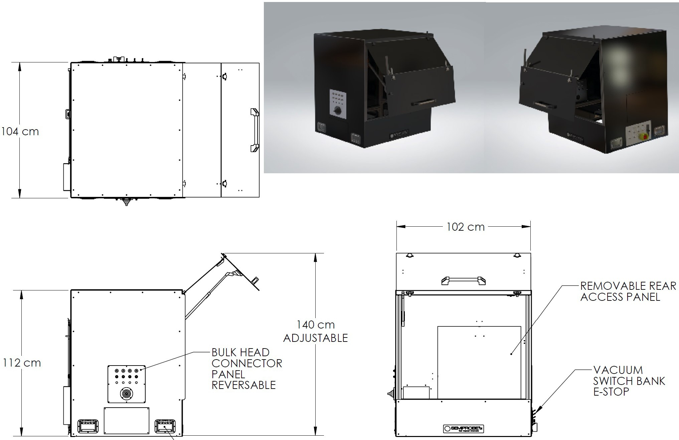
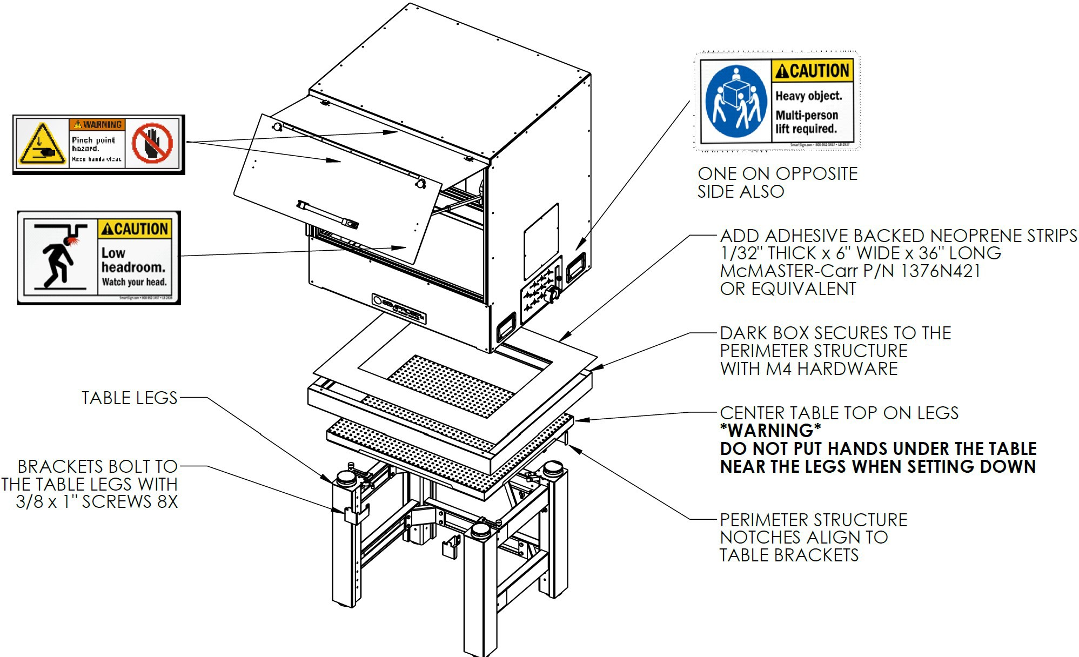

Copyright 2011 SemiProbe, Inc. All rights reserved. Probe System for Life and SemiProbe are registered trademarks. Lab Assistant, IRIS Wafer Inspection and Pilot control software are trademarks of SemiProbe, Inc. All other trademarks are the property of their own respective owners.
F
276 E. Allen Street, Winooski, VT 05404 P: 802-860-7000
info@semiprobe.com www.semiprobe.com

ROLL TOP DARK BOX Rev 2 0124

